EXPERIMENT 2 PROPERTY BUYING OR RENTAL

Step1: Build an application named property

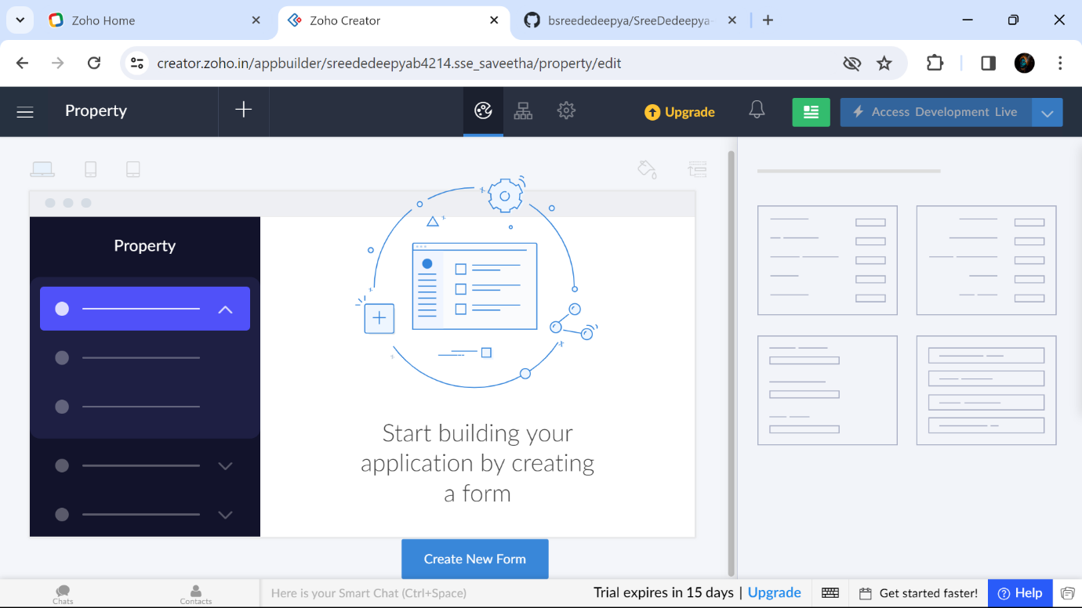

Step2: Create the form Personal details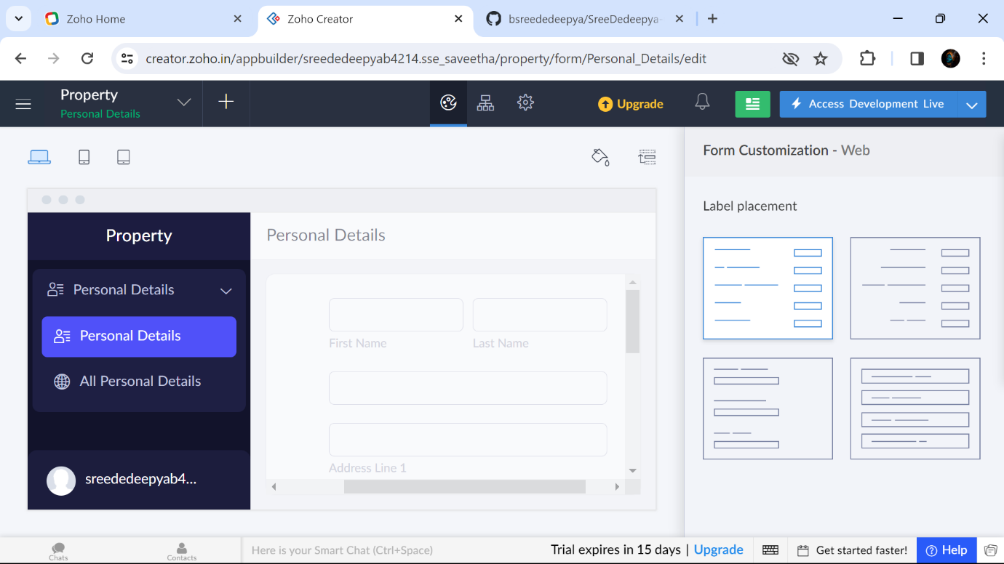

Step 3: : Create the form Property Buying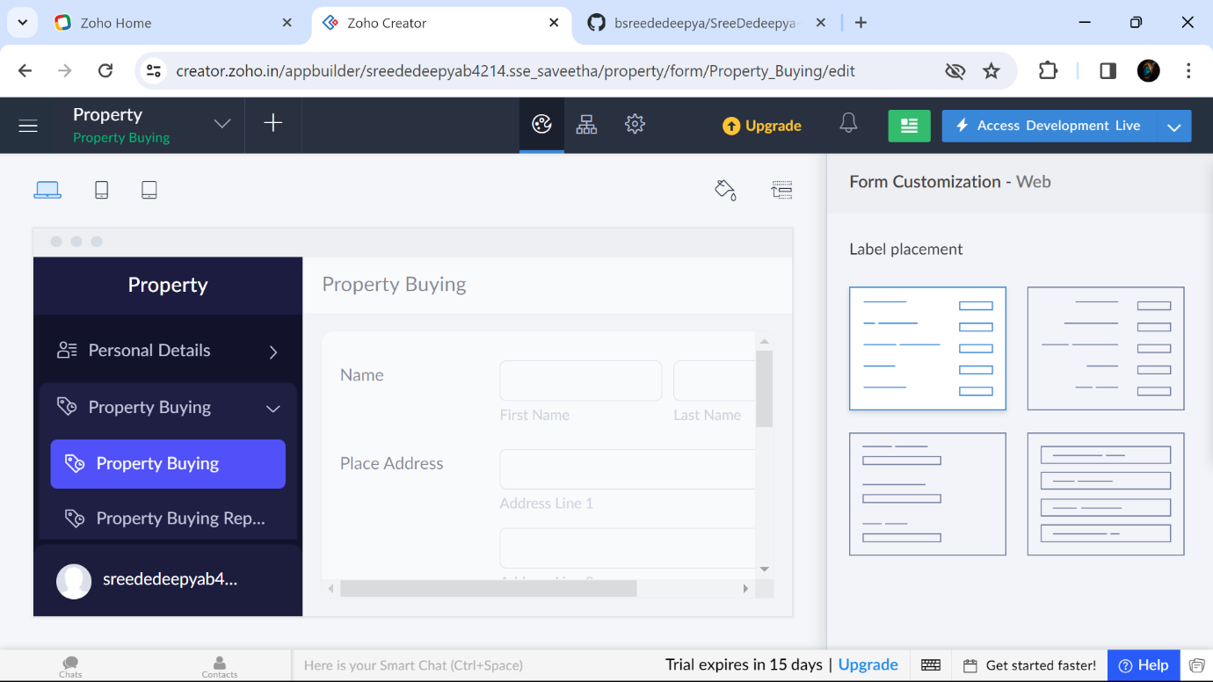

Step4: : Create the form Property Rental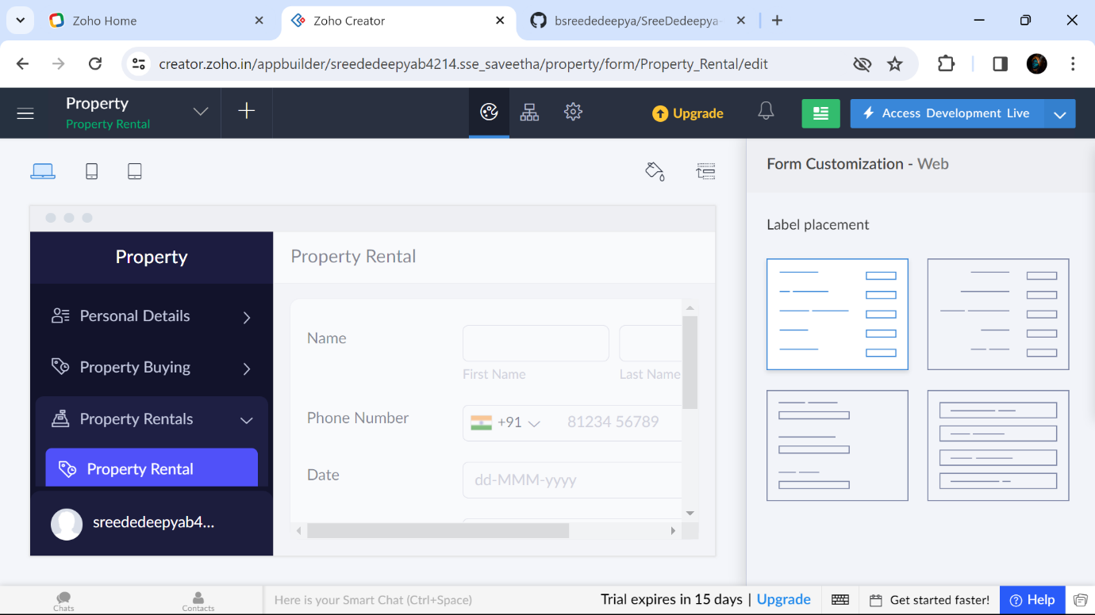

B.SREE DEDEEPYA 192224214

Step 5: Entered details in Form and this is the information in All Property buyings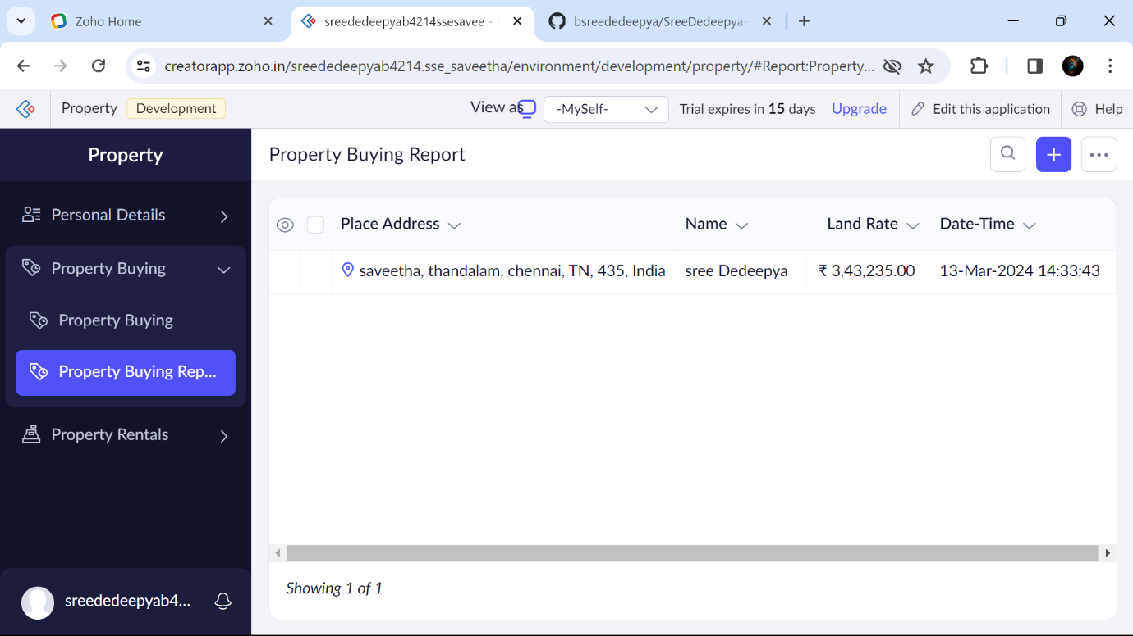

Step6: Entered details in Form and this is the information in All Personal Details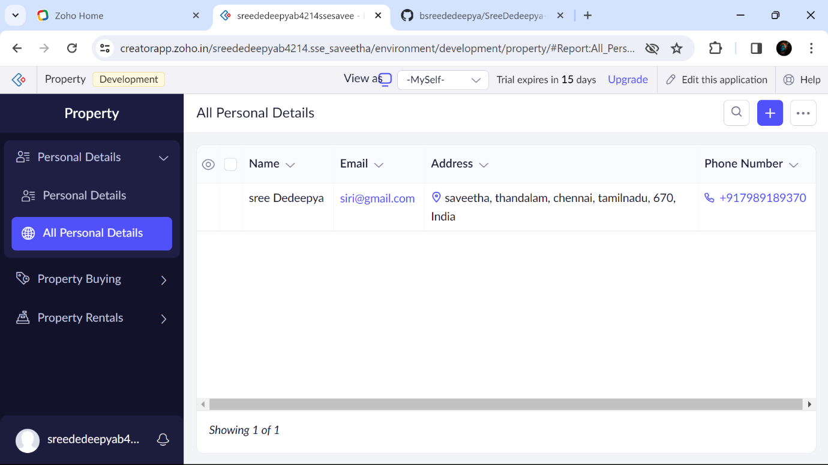

Step 7: Entered details in Form and this is the information in All Property Rentals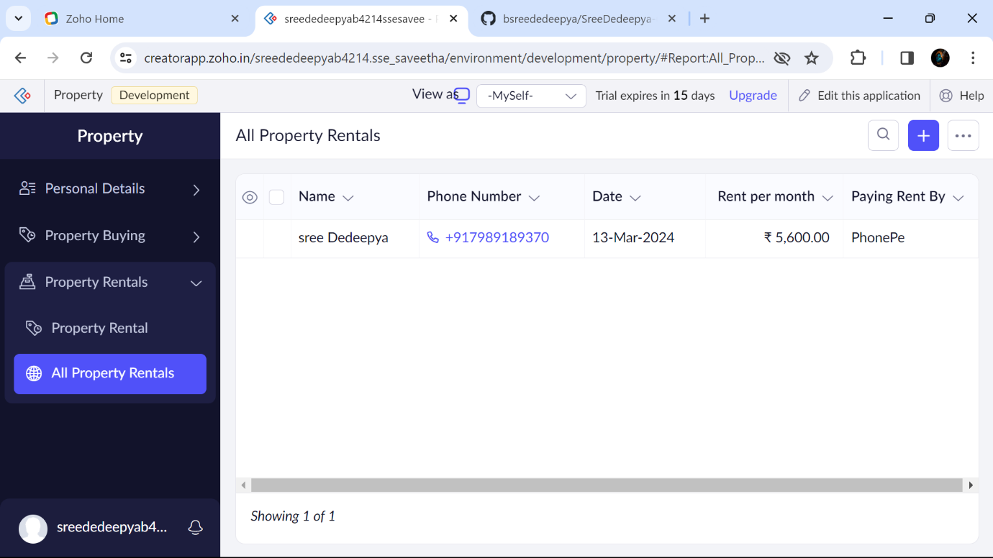

B.SREE DEDEEPYA 192224214